**

***LAB # 10***

FIFO Queue implementation using Stack and Linkedlist.

.

December 23, 2024

**

***LAB TASKS***

***TASK # 01***

1. Write a program to implement queue using link list and perform operations on it.

*INPUT*

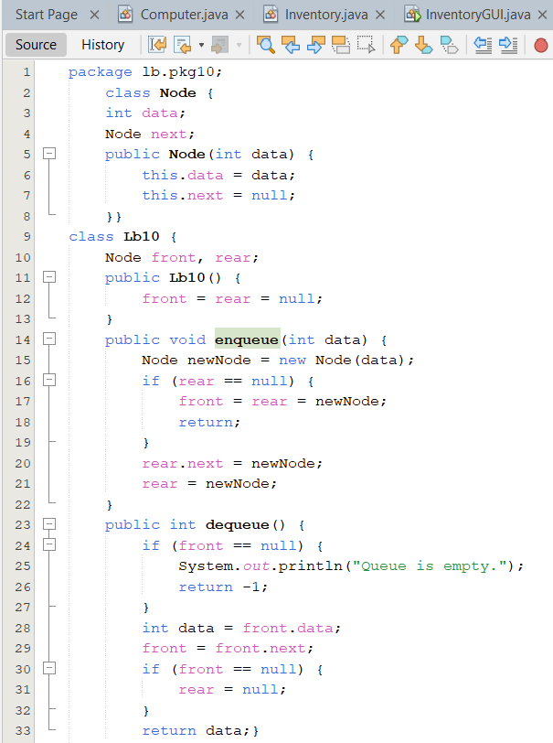

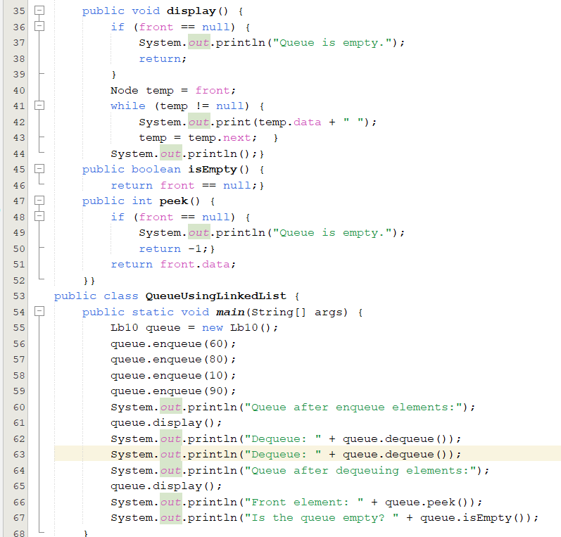

*OUTPUT*

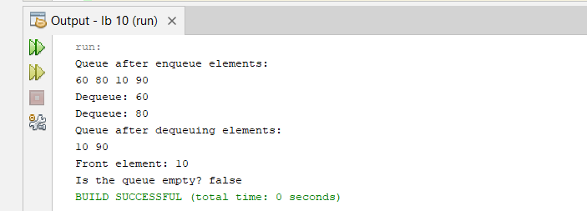

***TASK # 02***

1. In this problem, you need to implement a **Queue ADT** using an **array**. Your queue will support the following operations:
2. **Enqueue**: Add an element to the rear of the queue.
3. **Dequeue**: Remove an element from the front of the queue.
4. **Peek**: Retrieve the front element of the queue without removing it.
5. **IsEmpty**: Check if the queue is empty.
6. **IsFull**: Check if the queue is full.
7. **Size**: Return the number of elements currently in the queue.

*INPUT***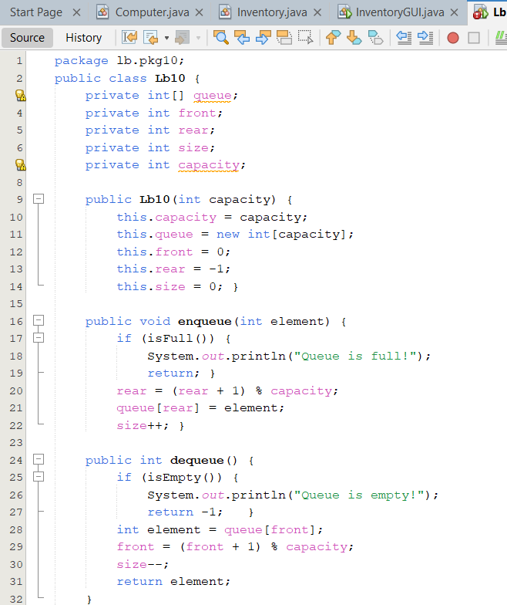**

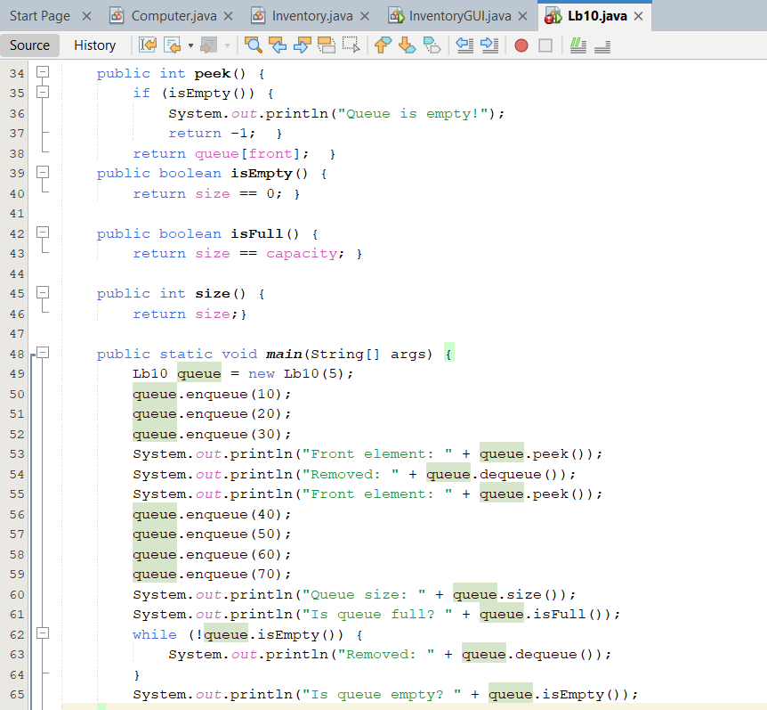

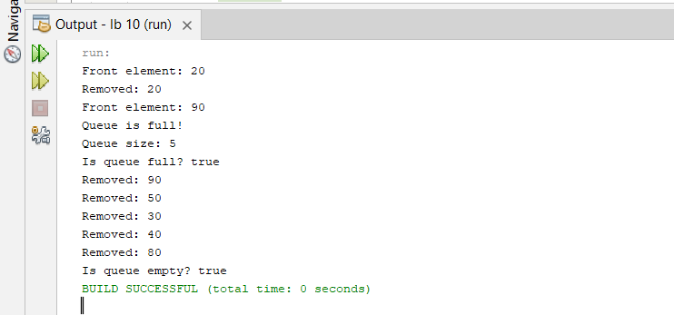

***TASK # 03***

1. You are managing a queue of tasks to be processed by a machine. Each task is assigned a priority, and you must process them in order of priority, with higher priorities processed first.Implement a queue where tasks are added with a priority, and each time you process (dequeue) a task, you must remove the task with the highest priority

*INPUT*

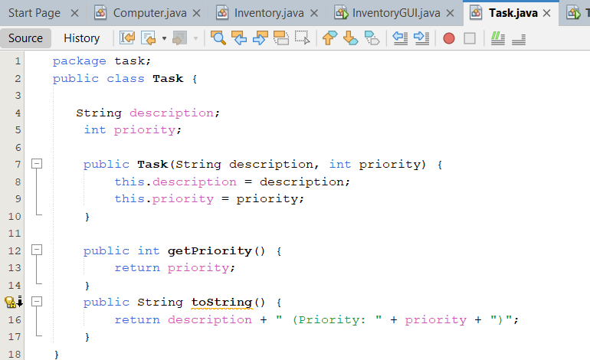

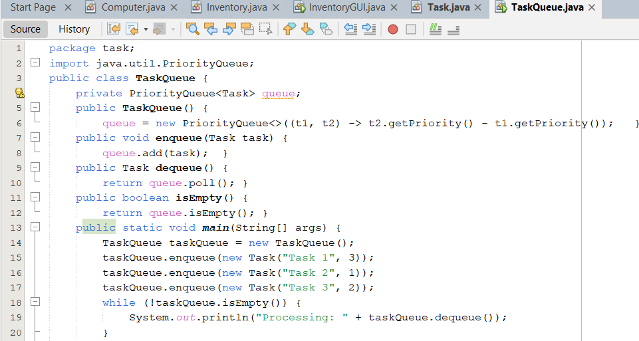

*OUTPUT*

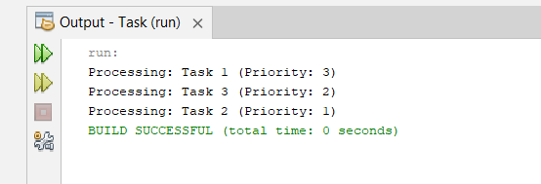

***HOME TASKS***

***TASK # 01***

1. Write a program that processes a group of input lines. Each input line contains an 'A' for arrival and a 'D' for departure, and a license plate number. Cars are assumed to arrive and depart in the order specified by the input. The program should:

a) Print a message whenever a car arrives or departs.

b) When a car arrives, the message should specify whether or not there is a room for the car in the garage. If there is no room, the car leaves without entering the garage.

c) When a car departs, the message should include the number of times that the car was moved out of the garage to allow other cars to depart.

*INPUT* 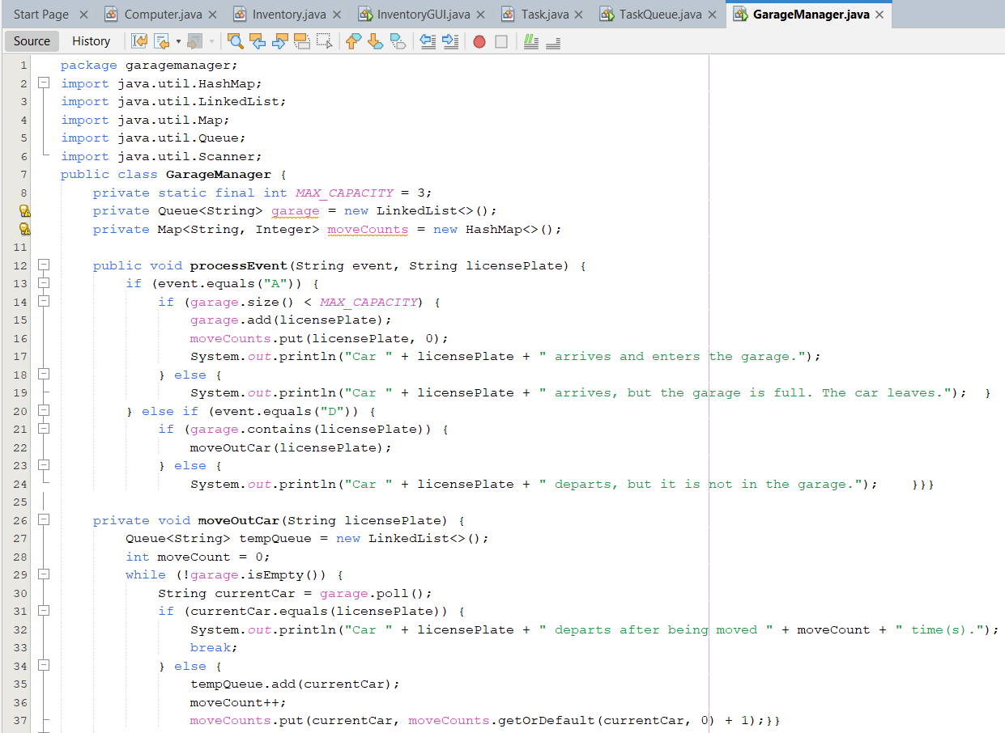

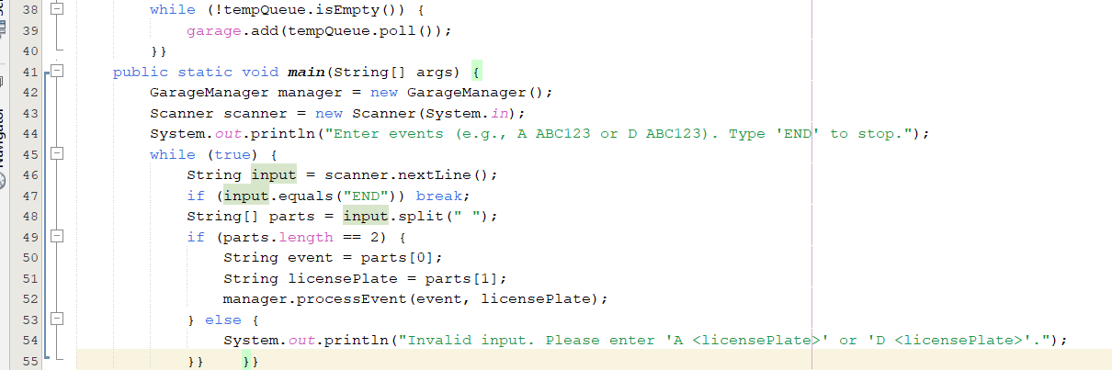

*OUTPUT*

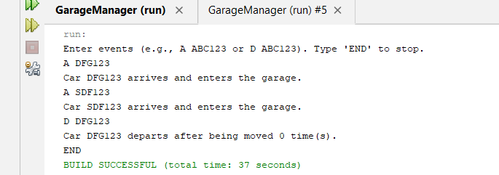

***TASK # 02***

1. Write a program to implement stack using queue.

*INPUT*

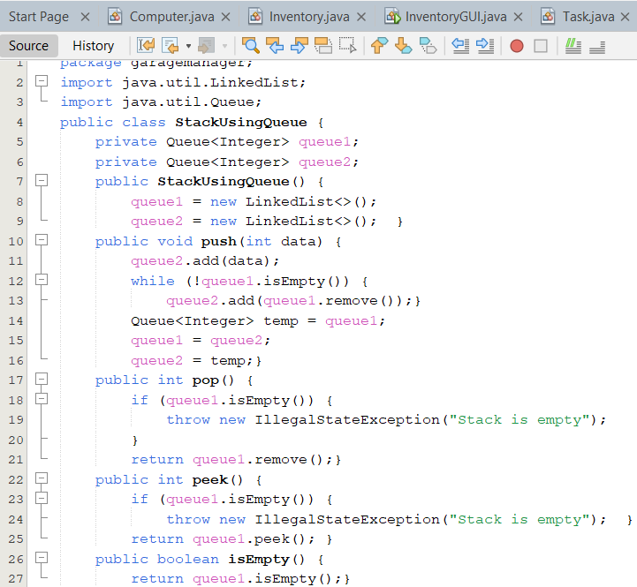

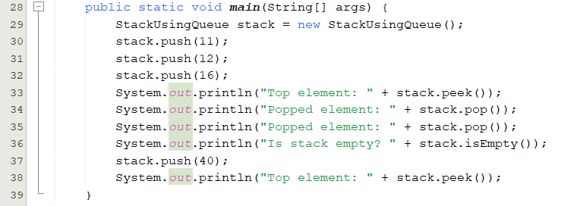

*OUTPUT*

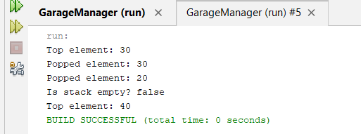

***TASK # 03***

1. You are simulating a waiting line for a ticket counter. Each person in the queue has a ticket number, and the queue will be processed based on the order in which people arrive. If a person’s ticket number is a multiple of a given number k, they will be processed (dequeued) before others, otherwise they will remain in the queue.

Implement the following operations:

1. **ENQUEUE ticket_number**: Add a person with the given ticket number to the queue.
2. **PROCESS k**: Process the person with the ticket number that is a multiple of k. If no such person is found, print "No person to process".
3. **SIZE**: Print the number of people currently in the queue.

*INPUT* 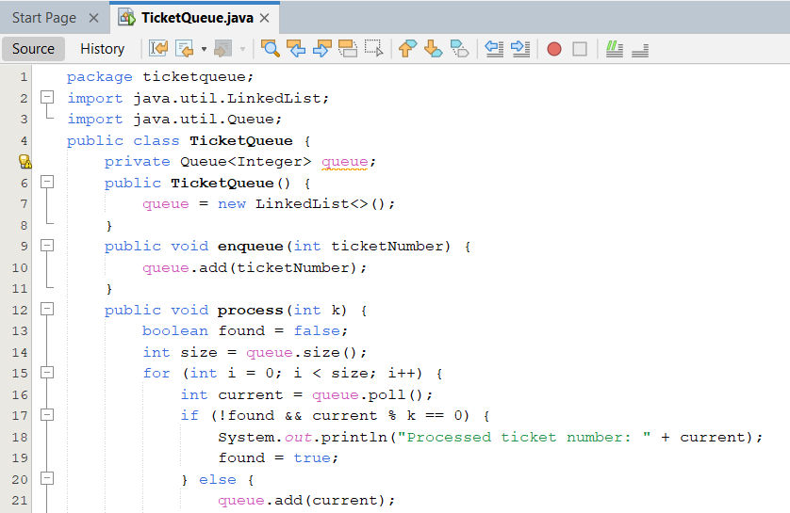

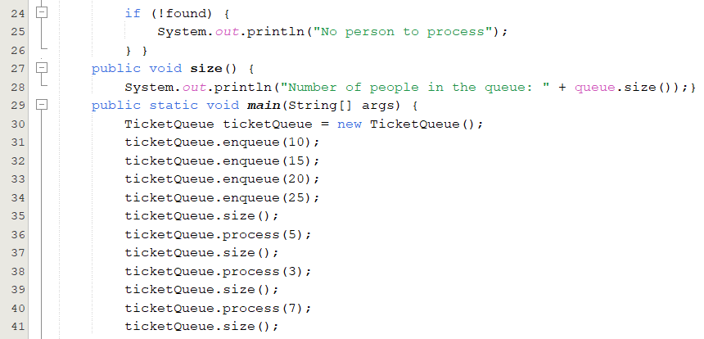

*OUTPUT*

